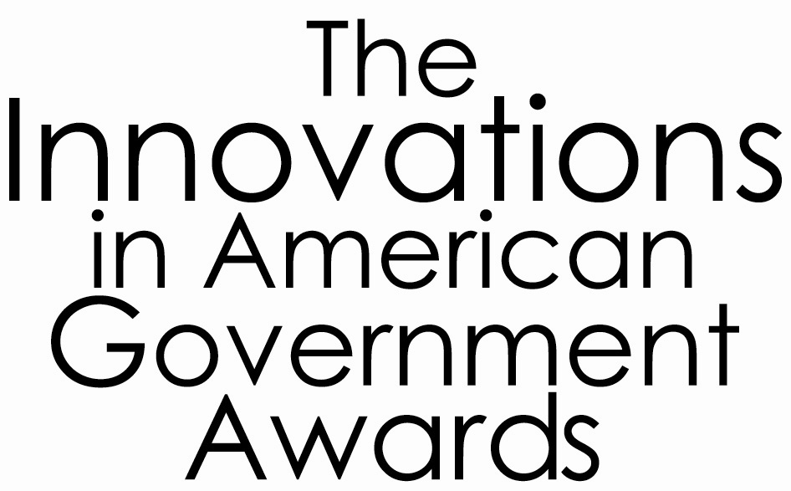



Embargoed for Release Contact: Sarah Howe
Wednesday, July 28, 2004 (202) 530-3270
showe@excelgov.org

EASTSIDE KING COUNTY’S “ARCH” WINS RECOGNITION FROM HARVARD & FANNIE MAE
Innovative Affordable Housing Program Wins New Innovation Award

(CAMBRIDGE, MA) – A one-of-a-kind organization created by Eastside cities and King County (WA) to preserve and increase the supply of housing for low and moderate income households in East King County has won the first-ever Fannie Mae Foundation Innovations in American Government Award in Affordable Housing.

A Regional Coalition for Housing (ARCH) will receive a $25,000 grant to support replication of its significant and creative efforts. The award is a partnership of the Fannie Mae Foundation and the Ash Institute for Democratic Governance and Innovation at Harvard University, which for the past 17 years, has honored the best and brightest public sector initiatives through its “Innovation in American Government Award” program.

ARCH assists households looking for affordable rental and ownership housing; provides financial support to groups creating affordable housing; and assists member governments in developing housing policies and programs. The organization was created eleven years ago with the specific goal to help suburban cities become more effective and efficient partners in community-wide efforts to meet local housing needs. Working through ARCH, suburban cities have an effective voice influencing regional and state policies, including distribution of resources, to more effectively serve suburban areas.

“It takes real creativity—as well as a true partnership between counties and cities—to leverage scarce resources and bring quality, affordable housing into the communities that need it. ARCH is leading the way and by shining a spotlight on this innovate organization, we hope that other cities and counties can learn from their amazing success,” said Stephen Goldsmith, Faculty Chair of the Ash Institute at Harvard’s Kennedy School of Government.

ARCH preserves and increases the supply of housing for low and moderate income households in Eastside King County by: coordinating public resources to attract greater private and not-for-profit investment; pools technical resources between jurisdictions to assist in the development and implementation of housing policies and programs; provides expert assistance to local organizations interested in becoming active in affordable housing; facilitates community involvement and leadership directed towards housing needs; and provides information to the community on local housing issues.

For 17 years, the Innovations in American Government Award has recognized quality and responsiveness at all levels of government, honored government efforts that are creative, effective and address significant problems, and has fostered the replication of innovative approaches to the challenges facing government. This new award focuses specifically on public policy innovation which supports the development and preservation of affordable housing.

-MORE-

About the Fannie Mae Foundation Innovations Award in Affordable Housing:
The Fannie Mae Foundation Innovations in American Government Award in Affordable Housing is a program of the Ash Institute for Democratic Governance and Innovation at Harvard University’s Kennedy School of Government. The award is sponsored by the Fannie Mae Foundation

The Ash Institute for Democratic Governance and Innovation fosters democracy worldwide by studying its principals, processes, and adaptations throughout the world and by examining and championing public sector excellence. Through its awards programs conducted in partnership with the Council for Excellence in Government, as well as its research and global network, the Institute explores critical issues in democracy, and disseminates and celebrates examples of effective governance.

The Fannie Mae Foundation creates affordable homeownership and housing opportunities through innovative partnerships and initiatives that build healthy, vibrant communities across the United States.

On the Web:

A Regional Coalition for Housing
(www.archhousing.org)

The Ash Institute for Democratic Governance and Innovation
(www.ashinstitute.harvard.edu)

The Fannie Mae Foundation
(www.fanniemaefoundation.org)

###

